**Assignment-6**

**Queston:**

**Complete the below task:**

**1.Explain the below AWS Architecture**

**2. Implement the same in the AWS(only do a proper connection between service)**

**ANS:**

**What is an Amazon EC2 instance?**

An Amazon EC2 instance is a virtual server in Amazon's Elastic Compute Cloud (EC2) for running applications on the Amazon Web Services (AWS) infrastructure.

So EC2 is IAAS, it’s infrastructure as a service. It provides access to virtual machines known as EC2 instances. Because its IAAS, the unit of consumption is the instance. An instance is just an Operating system configured in a certain way with a certain set of allocated resources. Now, EC2 is a private AWS service, it runs in a private AWS zone.

EC2 is AZ resilient means if AZ fails then the instance

AWS is a comprehensive, evolving cloud computing platform; EC2 is a service that enables business subscribers to run application programs in the computing environment. It can serve as a practically unlimited set of virtual machines (VMs).


   
   Automatically connect an RDS database with an EC2 instance
  

Elastic Load Balancing automatically distributes incoming application traffic across multiple Amazon EC2 instances. It enables to achieve greater levels of fault tolerance in your applications, seamlessly providing the required amount of load balancing capacity needed to distribute application traffic.

ELB routes traffic to Amazon EC2 instances.

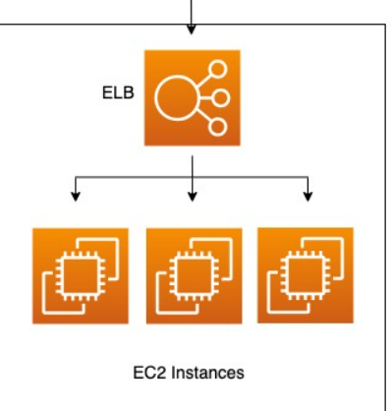



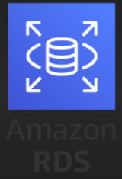

This diagram has 3 AWS services – ELB, EC2 and RDS.

1. Traffic from user will route to ELB and ELB will route the requests to EC2 instance as per traffic.

2. ELB is connected with EC2 to distribute all the traffic from user to EC2 to handle the load.

3. EC2 instances are connected with RDS database to store the relational data.

1. Created 3 EC2 instances namely MyWebServer1, MyWebServer2, MyWebServer3 on three different Availability zones

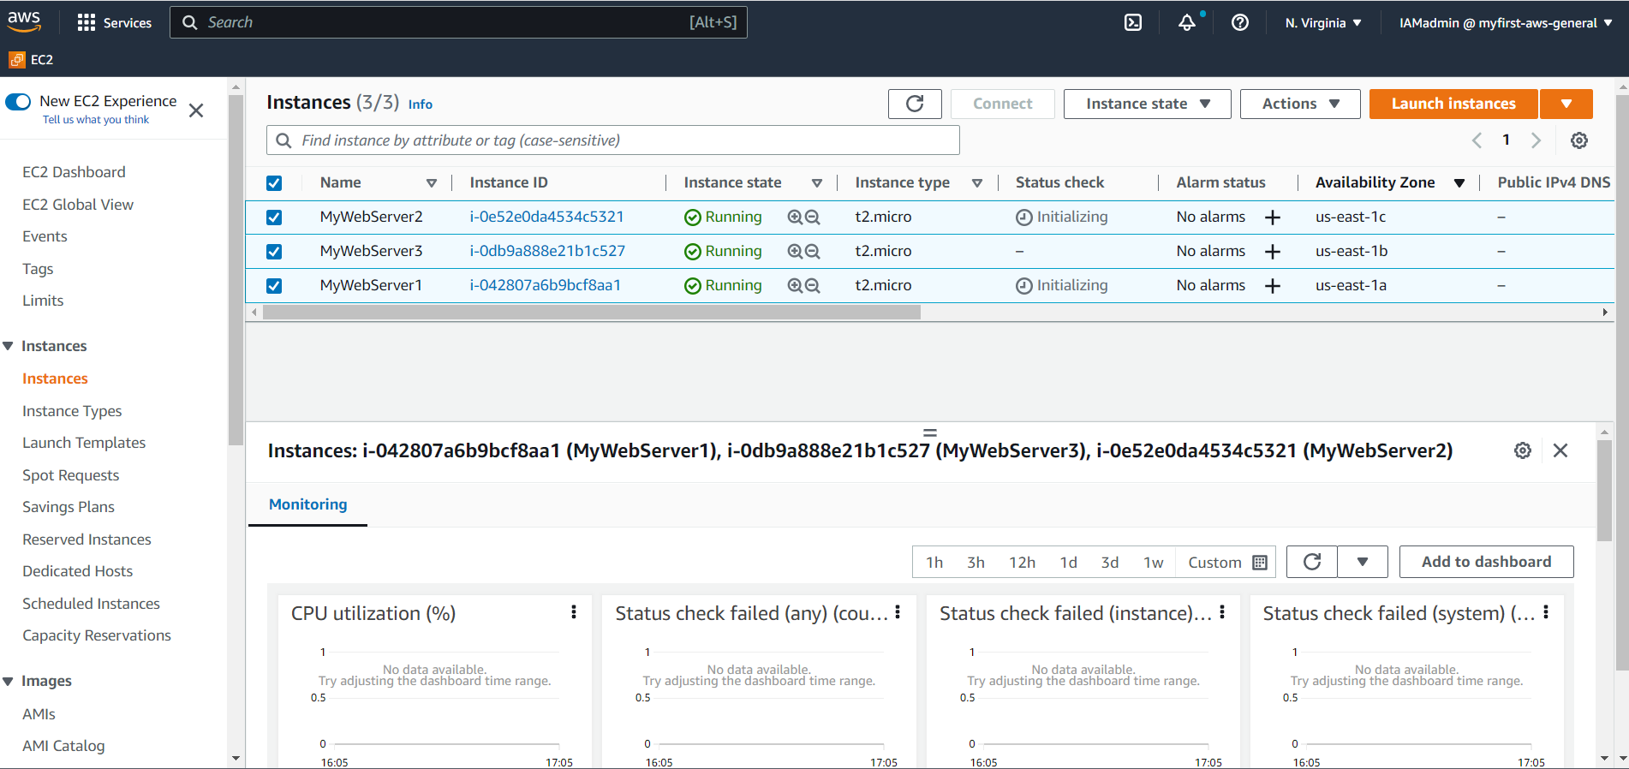

1. Created 2 different Security Group with All Traffic Inbound and Outbound rules

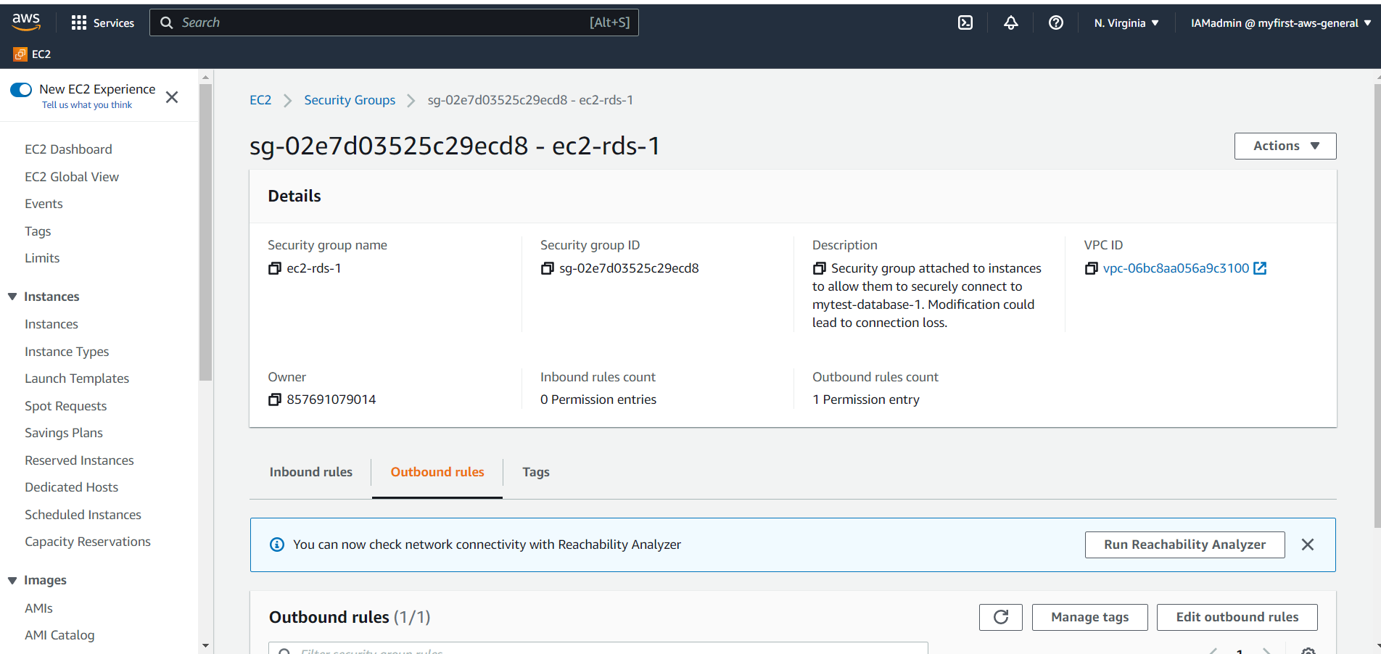

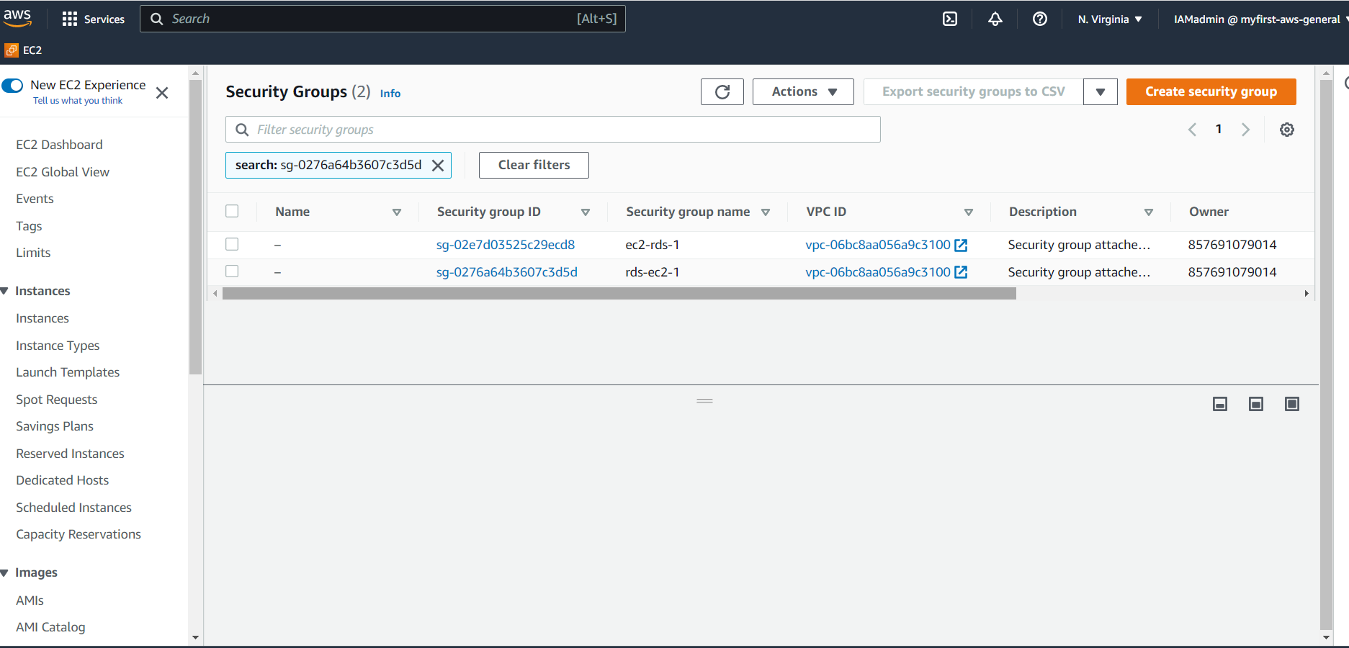

1. Created Elastic Load Balance (ELB) named as MyELB

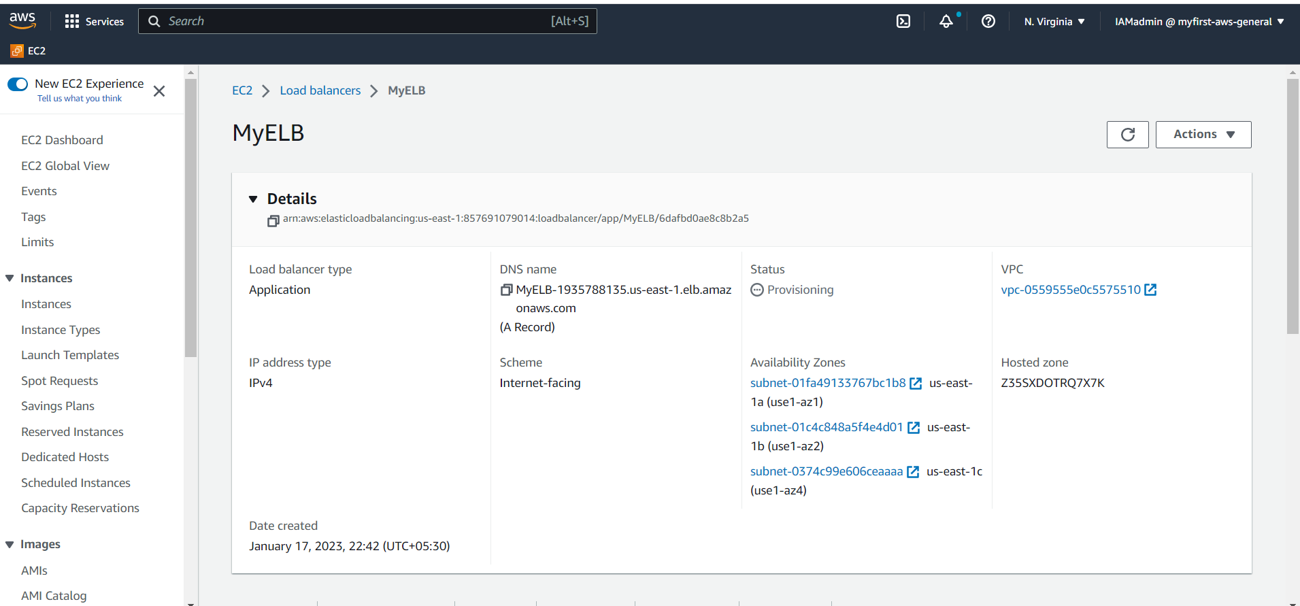

1. Created Target Groups and registered 3 EC2 instances

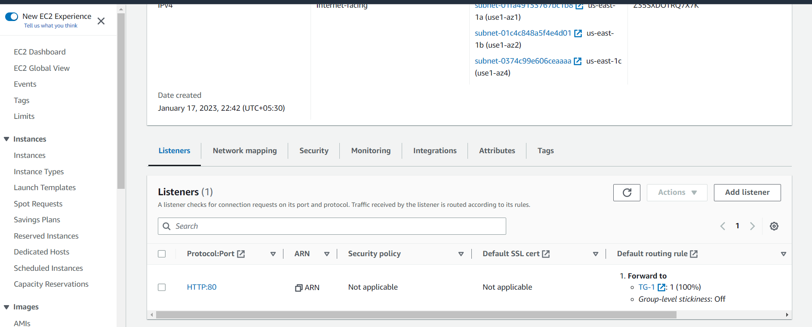

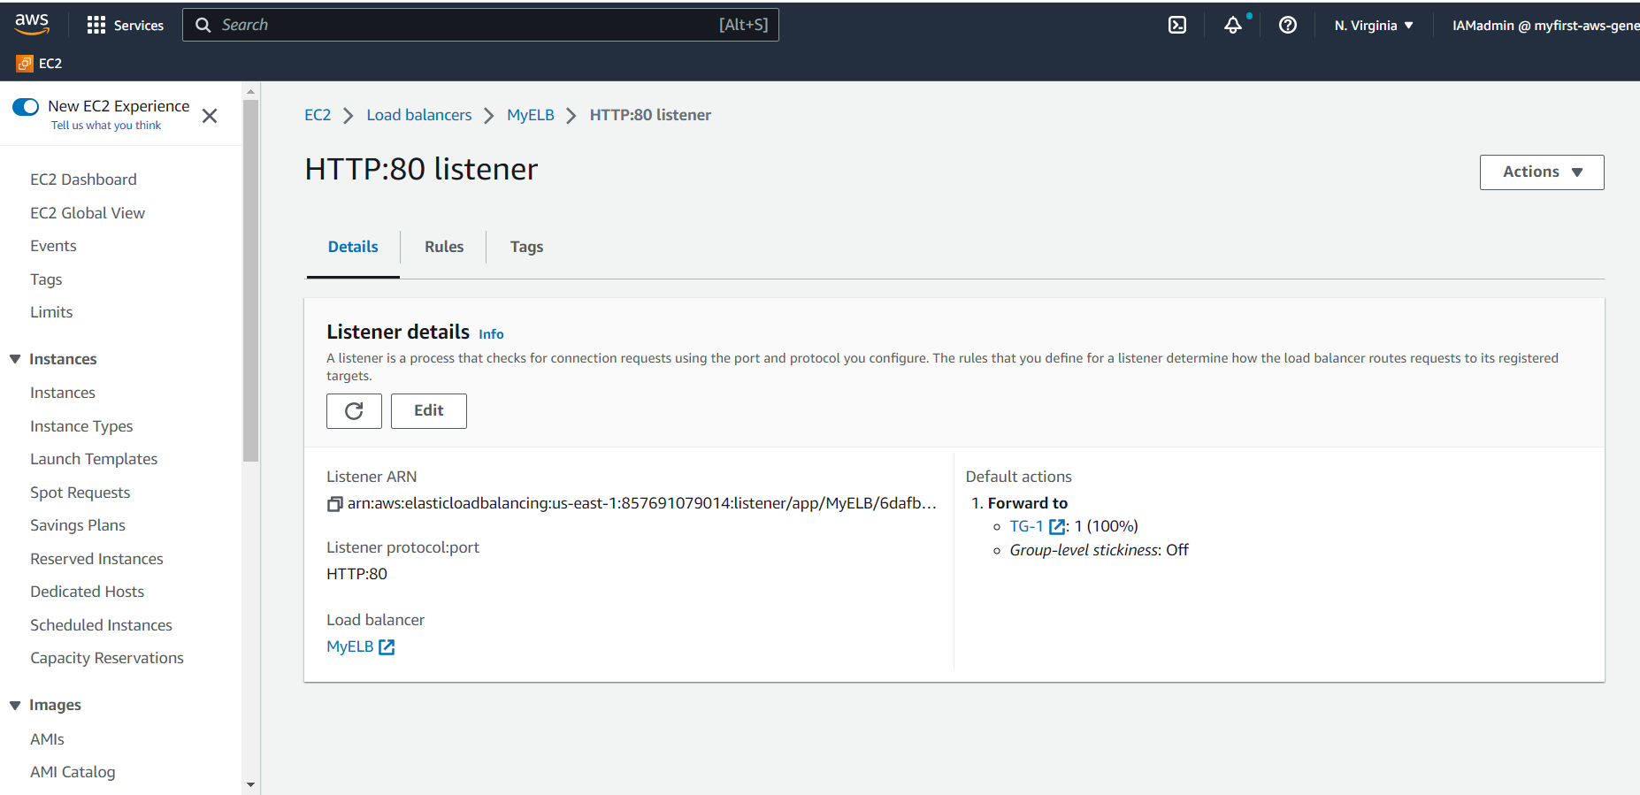

Load Balancer is responding.

1. EC2 instance MyWebserver-1 IP address : 172.31.0.108
2. EC2 instance MyWebserver-2 IP address : 172.31.31.46

Browse through ELB DNS

It redirects traffic to webserver 1 (IP : 172.31.0.108 ) after refresh it redirects to Webserver 2 (IP: 172.31.31.46)

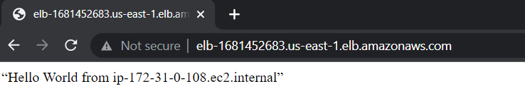

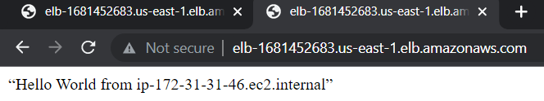

Load balancer is working.

1. Created RDS database “database-1”

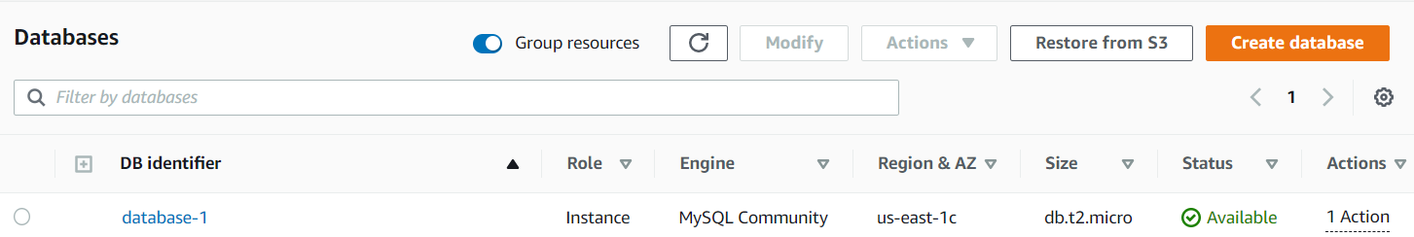

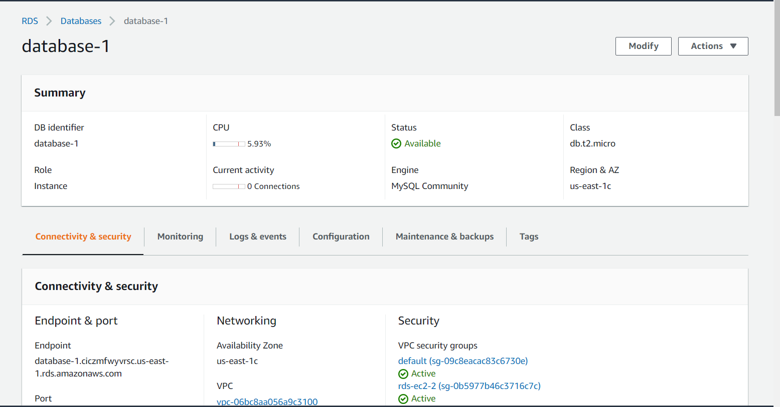

1. Connected EC2 instances to RDS database

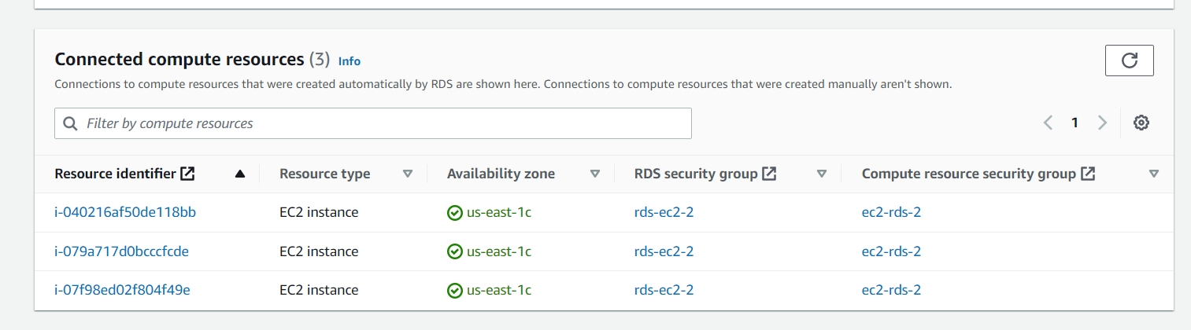

Connected ELB to EC2 instances and EC2 instances to RDS.